2020 Android 9.0 Smart WiFi 1080P Projector S4’s Different Features
Note: 2019 Smart WiFi 1080P Projector S4’s Solution is MST358.
2020 Smart WiFi 1080P Projector S4’s Solution is M948.
This is new appearance of 1080P Projector  These Two kinds of Appearances both are available, choosable. |  |  | 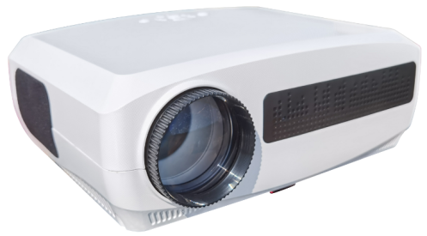
Smart WiFi 1080P LED LCD Projector | 2019  S4 | 2020  S4 | 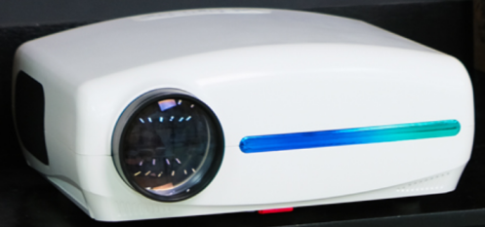
Solution | MST358 | M948 | Different Features
CPU | A53 Quad-core | A55  Quad-core | A55 is 60% faster than A53 with 40% less power, and 120% more calculation capacity.
GPU | Mali 820 | Mali G31 | Image rendering ability is a revolution for the older version GPU
RAM | 1G | 2G~4G | MST358 has only 1G RAM at most, and M948 can be expanded to be more than 3G.
ROM | 8G | 16G/32G | Obviously advanced
Android Version | 6.0/7.1 | 9.0 | 6.0 is a old and low version of Android released 4 years ago, and no longer compatible with latest APPs from Google Play. This will cause many puzzle to users.  Even 7.1, is old enough.  The latest 9.0 is a widely used Android Version for all the Apps and Google Play.  Stable, New, Great compatibility, fast, smooth.
OS | Android old system, or modified own version | The World First to adopt Google TV (Anroid TV/ATV)in the LCD projection industry, as Samsung, Sony, ROKU do in their TV systems.  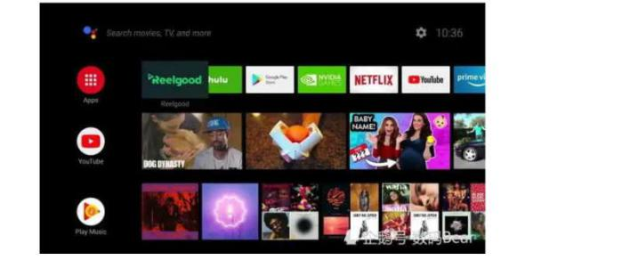  Original Google ATV OS supports all programs in GOOGLE PLAY;  We are sure most of the users like this OS, or there is few complains at least.
GOOGLE PLAY, YOUTUBE ,NETFLIX | These system use an Hacked Google Play in its OS. Each time when google play updated, these fake google play will collapse. And Youtube and Netflix rely on the GMS in google play,they will shut down working as well. | We adopted the factory copy of ATV, whick is an original copy for mass production. | We built a Hong Kong server, to maintain the factory copy released by Google, so as to upgrade it on time.  YOUTUBE, NETFLIX is genuine version based on google Play, it can work all the time even when the google play is in maintainance.
Setting | Most low end android projector has many settings inside, some from Android, some by themselves for projection mode, some from Chipset to set the image. The users are always looking for proper settings to set the projector  Our latest version, has only one setting with our best ATV UI, which can improve the experience a lot for users.
Supported Play format | M358 can only play 4K video in H.265 format with 30 frames(FPS);(Now in the world, among all the 4K videos, only 40% is in H.265 format)  M358 can not play 4K video on native 1080P projectors, as its CPU and GPU is not Strong enough.  We are the world first to play all the 4K video in the world even it is 60FPS in either H.264 or H.265. (say, 100% all 4K sources)  Moreover, our chipset M948 is the world first to play 8K video in 24 FPS.
Speaker | Both S and BB series have sound chambers;  The BB series, with 300CC sound chamber, adopts anti-shock technology;  With the latest DSP Chipset support, the sound is beautiful in bass and treble.  For users, our new projector BB series is a high quality Bluetooth Speaker , and a beautiful projector, and a wonderful home appliance.

