**HS130 Brass compression fitting female threading for PE pipes (Heavy type)**

HONSON HS130 Brass Compression Fittings female threading for PE pipes are specifically designed according to DIN8076-1 for use on water distribution.

HONSON HS130接PE管黄铜内螺纹连接卡套管件是根据DIN8076-1标准，专为水路系统设计的。

**结构**

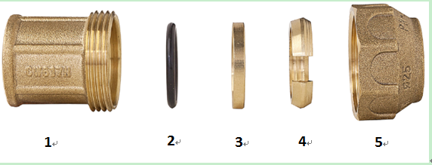

|  |  |  |
| --- | --- | --- |
| **Item** | **Description** | **Materials** |
| 1 | Body本体 | CW617N-DW |
| 2 | O ring O形圈 | EPDM |
| 3 | Washer ring 平垫片 | CW617N-DW |
| 4 | Compression (C-Ring)开口卡子 | CW617N-DW |
| 5 | Nut螺帽 | CW617N-DW |

**特点**

1. 适用卫生管道系统和暖通系统
2. DVGW认证
3. 符合DIN8076-1标准
4. 适配低密封PE管、中密度PE管和高密度PE管
5. 体帽红冲，黄铜材质符合UNE-EN12165标准
6. 规格齐全20-63MM
7. 工作温度-10°C 到 + 80°C
8. 最高工作压力：16BAR (PN-16)
9. 可追溯性