ST-1000 Energy Storage Power Specification

ⅠProduct description
ST-1000 standby power supply for our company a high-end fashion power supply products, using aluminum alloy shell material, light portable, stylish appearance, the core of the power type lithium battery, advanced manufacturing technology, power output energy, provide AC output, DC output two different voltage mode output, to meet the user electronic products charging, AC electricity, and other aspects of electricity demand. This product can be used as both UPS power supply and outdoor emergency backup power supply.
This product has built-in large capacity lithium battery, total capacity 1065.6WH,288000mAh. Providing a steady stream of power for the load. It is also widely used as a backup emergency power supply for indoors and outdoors.
220V (110V) AC output,12V/5V DC output, with LED lighting, with electricity display. Suitable for a variety of different equipment, such as drones, portable ventilators, medical devices, mobile phones, tablet computers, laptops, desktop computers, small printers, various lamps, small fish tanks, photographic equipment, electric scooters, etc. Great convenience for users to travel at home, outdoor work, camping picnics, mountaineering expeditions, etc.

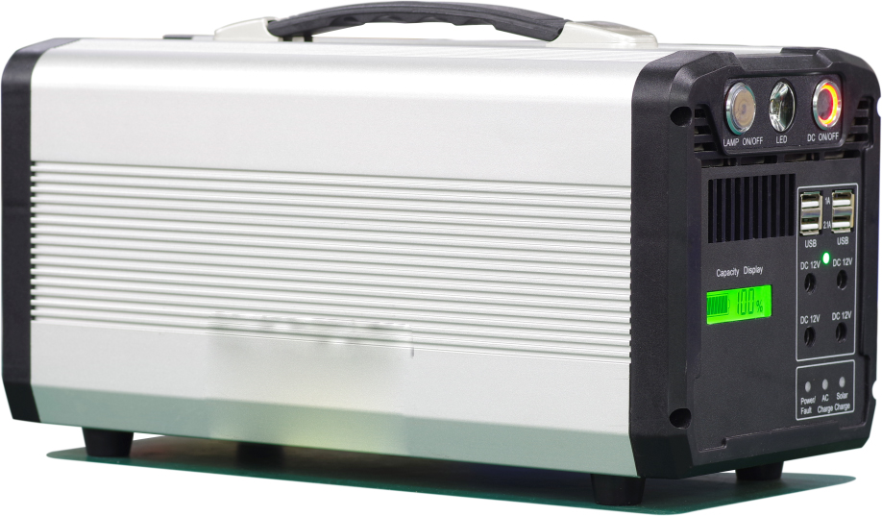

Product advantages:
- We develop and design circuits ourselves. We purchase the raw materials ourselves. We produce and process ourselves. We conduct quality inspections ourselves. Our own appearance patent. Our own invention patent
- Built-in charging function, built-in UPS function, built-in high-frequency inverter technology.
- Buy portable lithium battery technology, greatly reducing the volume and weight of the product.
- It adopts the technology of charging while using, which is convenient for users to use.
- A variety of charging modes, mains electricity charging, solar charging, car charging three charging modes.
- The shell is made of aluminum alloy and can be used even at high temperatures.
- Using AC output at the same time, you can also use DC 12V,5V USB, LED lighting.
- Electricity always shows the current data, low voltage with alarm warning, high temperature with overheating protection, over-loaded with power protection, input with power protection and after short circuit with protection.
- All the products have been tested by the national certification body, and the quality is guaranteed.

Ⅱ Function Introduction and instructions for use
Front panel description

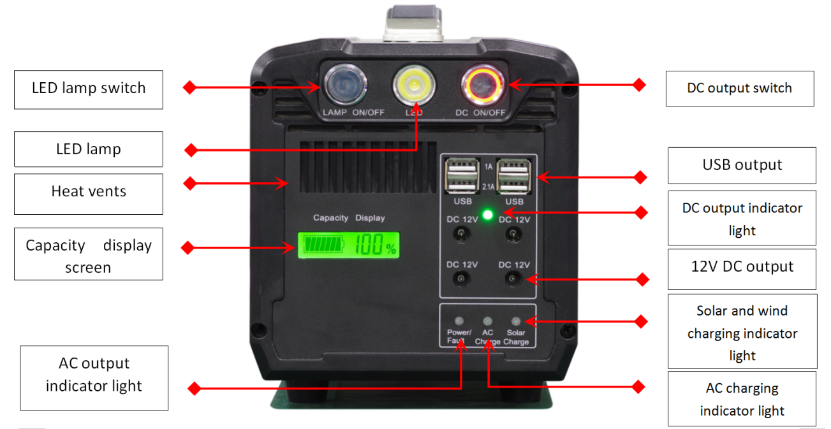

When using DC output function, please press the corresponding DC button, at this time can use DC 12V and 5V USB. When not in use, please turn off the button so as not to cause power consumption. The LED display screen shows the remaining power of the power supply,0~100%. When the power is insufficient, there will be alarm prompt, please charge in time for continued use. When using LED lighting, please turn on the corresponding button.

Rear panel description
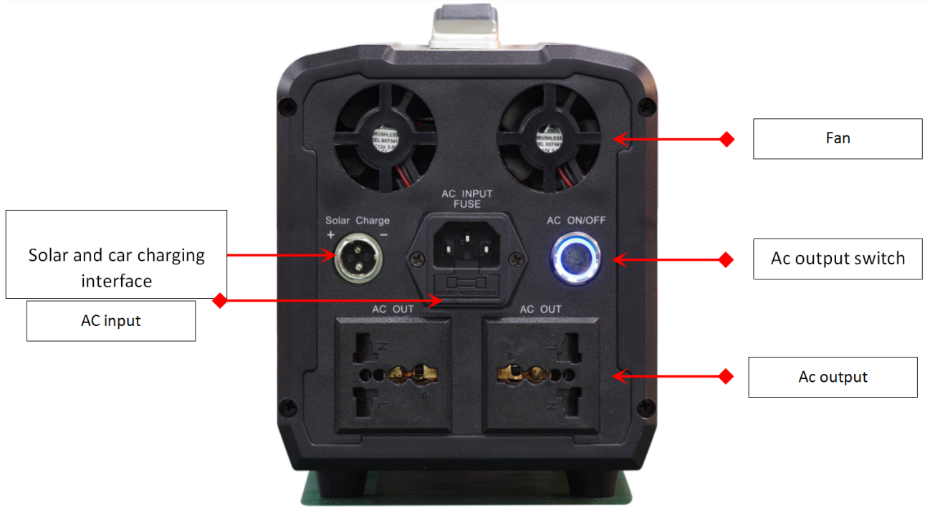

- When using the AC output, please turn on the AC switch first, confirm that the AC LED indicator on the panel is displayed as a green light, and then insert the electrical appliance into the AC output port. Do not use when turning on the AC output switch and the LED indicator on the panel is red.
- When using the UPS function, please first insert the input AC line into the AC input socket, then insert the AC line into the mains electricity, the input indicator on the panel is green, and the charge indicator light is on, indicating that it can be used normally. When the AC button is turned on, the AC output indicator is green, and then the electrical appliance can be plugged into the AC output socket. Then you can use the UPS function.
- When using solar power to charge the product, the voltage should not exceed 18V, more than will damage the machine, when the solar panel is connected to charge, the corresponding indicator light on the panel is bright, if not bright, please check not to connect back or the solar panel face the sun at the wrong angle (keep at 30 degrees angle).
- When the electricity is charged to the product, the charging indicator light on the panel during the charging process is red and green when it is completely full, and when the electricity quantity is shown to be 100, the actual battery has more than 90% capacity and can be used. do not have to wait until the charging indicator lights are completely green.
- When using a car-mounted cigarette lighter to charge the product, the indicator light corresponding to the solar charging port will be lit and can be used when the electricity quantity is shown to be 100. This product only supports charging on a 12V car.
- When the power of the appliance exceeds the power that the product itself can carry, the machine enters the protective state, disconnects the load, and restarts the machine.
- When the high temperature weather, the product in the process of use, may be overheated into the protection, please put the machine in a cool place to use.
Ⅲ Electrical parameters

product model | ST-1000
battery capacity | 1065.6Wh 288000mAh
output power | Rated 1000W, Max 1030W Overload Protection
input voltage | AC 110V~220V 50/60Hz
output voltage | 220V 50Hz or 110V 60Hz 2 versions
DC output | 4-channel 12V regulated output total current 10A, two 5V 3A USB output (with short circuit and overload protection function)
LED lamp | 1W
Solar charging | Standard 12V, allowed charge power 100W. (More than 100 W solar panels can only be filled with 100W)
Car charging | Using a solar charging port, allowing a voltage of 12V and a charge power of 100W
Output waveform | AC pure sine wave
UPS blackout reaction time | Within 10 ms
AC overload | No output after overload, disconnect load, restart recovery
AC Short circuit | No AC output short circuit, short circuit will damage the machine
lithium battery | Cycle life more than 800 times
weight | N.W:7.2kg G.W: 7.8kg
size | 14*16.7*36cm（W*H*L）
color | Silver body black panel, gray body yellow panel

Ⅳ detail specifications
Number | Project | Parameters standard
1 | mains electricity input voltage | Support AC wide voltage, wide frequency input
2 | mains electricity input fuse | 220V/6A ,110V/10A
3 | Switching time between mains electricity and inverter | Within 10ms
4 | Inverter AC output voltage | - No-load 220V output voltage between 220-226V  - No-load 110V output voltage between 110-116V
5 | Inverter AC output frequency | 220V/50HZ and 110V/60HZ ( Two frequencies)
6 | Inverter AC ripple voltage | Less than 700 mv
7 | Inverter AC output waveform | AC pure sine wave
8 | Inverter AC rated power | - 220 V rated power 1000 W,1030 W overload protection  - 110 V rated power 1000W,1030W overload protection
9 | Discharge efficiency standards | - When the battery voltage is above 16V, the efficiency is 95%  - When the battery voltage is above 14V, the efficiency is 96%  - The efficiency is 80% when the voltage is below 12 V  - Average efficiency 86%
10 | Battery power parameters | - When the battery voltage is higher than 18V, overvoltage protection, no external output.  - When the battery voltage is below 13V, undervoltage protection, no external output.  - When the voltage is below 13.8 V, the buzzer alarms.  - when the battery voltage below 12 V automatically shut down.  - when the voltage and voltage return to 14.4V above the automatic boot.
11 | Solar charge Standard | - circuit design for boost constant current to battery charge, PWM mode  - The solar input voltage range is 6-18V.  - Boost constant current after re-large the power allowed to charge into the battery does not exceed 100 W.  - The most powerful solar panels can only be filled with 100 W power.
12 | car charging standard | - Car charging is only for small 12V cars.  - 24V large cars are not suitable for products and will damage the products.
13 | Mains electricity charging time | - Charge current 8.0A,can charge the battery to more than 90% in 7 hours  - It can be used when the electricity quantity is shown to be 100%.  - The fully charged standard is that the charging indicator lights turn green within 9 hours.
14 | working temperature and protective temperature | When the temperature of the internal mainframe radiator reaches 50-55 degrees, the fan automatically starts to work for external heat dissipation; when the temperature of the internal mainframe radiator reaches 85-90 degrees, the machine automatically shuts down and does not output AC to the outside.
15 | 12V output parameters | - The 12V voltage output is stable between 12V and 12.6V  - four 12V outlets share a steady voltage module  - The total output current is 10A.  - With overload protection and short circuit protection function.
16 | USB 5V output parameters | - 5V voltage output is stable output between 5V and 5.2V  - two 5V output ports share a steady voltage module  - The total output current is 3A.  - With overload protection and short circuit protection function.
17 | Average power consumption | - The average internal power consumption of the DC part is 0.5W.  - The average internal power consumption of the AC part is within 7W.
18 | LED Light Indicator Standard | - AC indicator for normal green light, malfunction red light  - AC charging indicator light red when charging, green light when fully charged  - Solar charging indicator light red when charging, green light when fully charged
19 | Electricity Display Standard | - Battery power display 0-100% as standard  - When the battery power is displayed at 100%, the battery capacity is more than 90%
20 | Lighting function | The LED light has a power of 1 W.
V Schematic diagram of internal PCB board

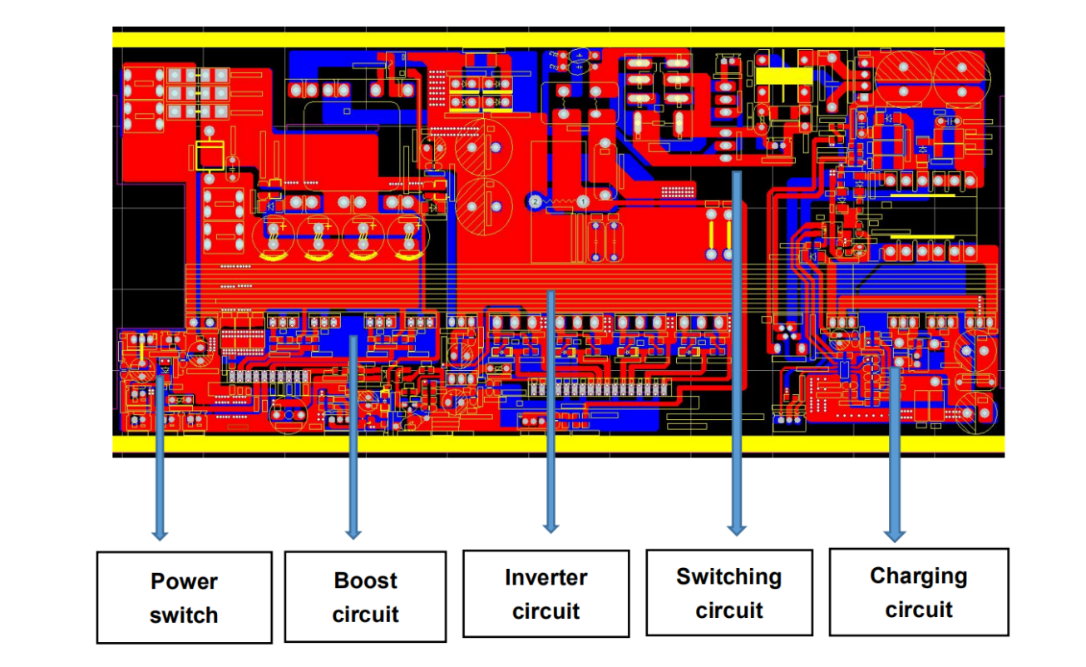

Ⅵ functional schematic:
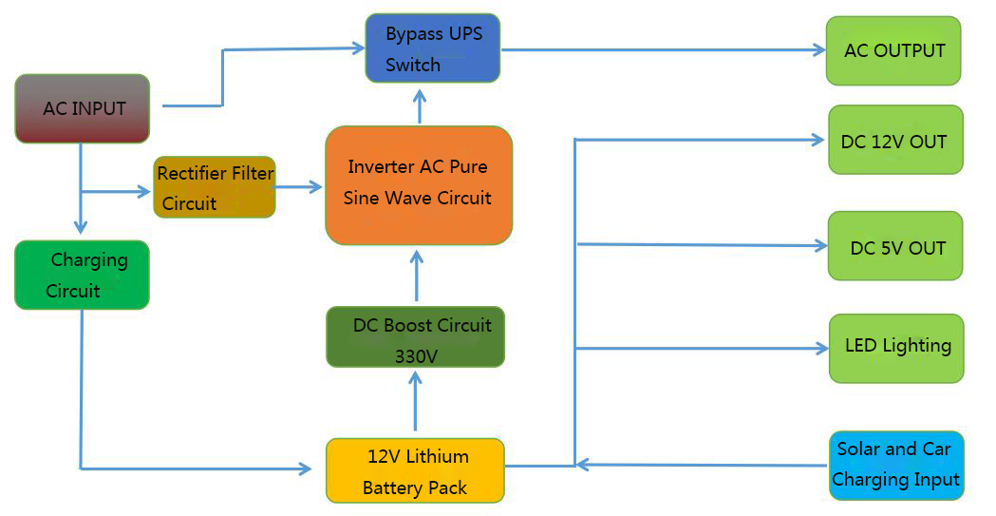

Ⅶ Packing list

Number | Number | Quantity
1 | UPS Power mainframe | 1
2 | AC power line | 1
3 | Car charging line | 1
4 | DC adapter line | 1
5 | Instructions, warranty cards and certificate | 1
6 | Solar charging line（Option）
7 | 12V 100W solar panel（Option）

